**Digital Transformation: Enhancing IoT**

**-**

**driven Solutions for Smart Islands**

___________________________

Dr. Farzad Ebrahimi

Chairman of IoT Academy

ITU Expert

ebrahimi@iotaci.com



Smart Island and its capability for smart agriculture



Hamid Naghizadeh

Researcher in the field of smart

agriculture

h.naghizadeh@iotaci.com

# Farzad Ebrahimi

CEO of IoT Academy (ITU Academia Member & ITU IoT Center of Excellence in Asia-Pacific)

Faculty Member in ICT Research Institute

International Internet of Things (IoT) Speaker & Lecturer

International Telecommunication Union (ITU) Expert

Chairman of The corresponding ISO/IEC JTC1 SC41 (Internet of Things and related technologies Standards) in Iran

Chairman, Member of the founding board and the board of trustees of Non-Commercial Institute (as a NGO) of “Promoting the Internet of Things and data science” at national level.



Doctor of Business Administration from the University of Tehran, MBA, M.Sc in Electrical EngineeringTelecommunication systems, B.Sc in Electrical Engineering- Electronics.

**Other Records:**

Counselor of the Director of ICT Research Institute

Superintendent of IT Faculty in Iran Telecom Research Center

Deputy of IT Faculty in Iran Telecom Research Center

Head of Multimedia Systems Research Group in Iran Telecom Research Center

Project Manager, Consultant and Observer of more than 50 Regional and National ICT related Projects.

**Hamid Naghizadeh**

**Education:**

MSc. – Agricultural Engineering, Animal Physiology BSc. – Agricultural Engineering, Animal Sciences

**Professional Experience:**

Research activities at Iran's national animal breeding and promotion of animal products center



Research activities at Iran's ministry of agriculture

Work and research experiences in the livestock and poultry farms

Head of the Group “Students of Animal Sciences” (student society(

**Areas of Interests:**

Smart Agriculture

Precision Farming

Applications of IoT and AI in the developing farms

# Outline

**1**

**. Introduction to the**

**agriculture**

✓

Terminology

✓

Definitions

✓

Agriculture as art,

science and

business of crop

production

✓

Branches of

Agriculture

**2**

**. IoT**

**-**

**Enabled Smart**

**Agriculture**

✓

Introduction

✓

IoT Ecosystem

Architecture for

Smart Agriculture

✓

Typical

Applications of

IoT in Smart

Agriculture

**3**

**. Precision Farming**

✓

An Introduction to

Precision

Agriculture

✓

The need for

precision

agriculture

✓

Tools of precision

agriculture

**4**

**. Climate**

**-**

**Smart**

**Agriculture**

✓

Why climate

-

smart

agriculture,

forestry and

fisheries?

✓

Water

management

✓

Soils and their

management for

Climate

-

smart

agriculture

**5**

**. Smart agriculture in**

**the Islands**

✓

Smart Islands

✓

The capability of

smart Islands for

smart agriculture

✓

Climate Smart

Agriculture in

Small Island

Developing

States

**1**

**. Introduction to the Agriculture**

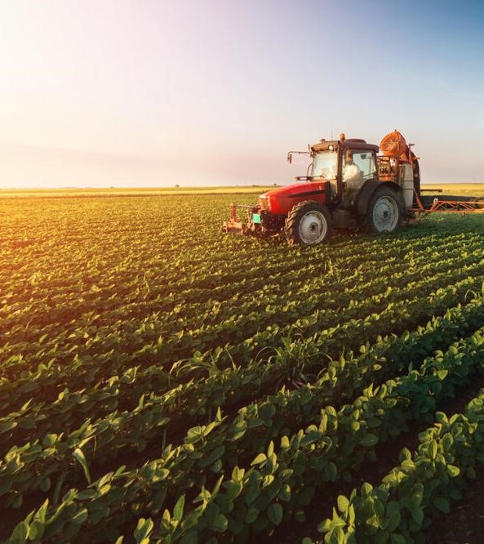

## 1. Introduction to the Agriculture

### 1.1 Terminology

Agriculture is derived from the Latin words Ager and Cultura. Ager means land or field, and Cultura means cultivation. Therefore the term agriculture means cultivation of land. i.e., the science and art of producing crops and livestock for economic purposes. It is also referred to as the science of producing crops and livestock from the earth's natural resources. The primary aim of agriculture is to cause the land to produce more abundantly and, at the same time, to protect it from deterioration and misuse. It is synonymous with farming–the production of food, fodder, and other industrial materials.

## 1. Introduction to the Agriculture



### 1.2 Definitions

Agriculture is defined in the Agriculture Act 1947 as including ‘horticulture, fruit growing, seed growing, dairy farming and livestock breeding and keeping, the use of land as grazing land, meadowland, osier land, market gardens, and nursery grounds, and the use of land for woodlands where that use ancillary to the farming of land for Agricultural purposes”. It is also defined as ‘purposeful work through which elements in nature are harnessed to produce plants and animals to meet human needs. It is a biological production process that depends on the growth and development of selected plants and animals within the local environment.

## 1. Introduction to the Agriculture

### 1.3 Agriculture as art, science and business of crop production

Agriculture is defined as the art, science, and the business of producing crops and livestock for economic purposes.

**As an art:** it embraces knowledge of how to perform the farm's operations skillfully. The skill is categorized as follows;

Physical skill: It involves the ability and capacity to carry out the operation in an efficient way, e.g., handling of farm implements, animals, etc., sowing of seeds, fertilizer and pesticide application, etc.

Mental skill: The farmer can make a decision based on experiences, such as (i) time and method of plowing, (ii) selection of crop and cropping system to suit soil and climate, and (iii) adopting improved farm practices, etc.

## 1. Introduction to the Agriculture

### 1.3 Agriculture as art, science and business of crop production

**As a science:** It utilizes all modern technologies developed on scientific principles such as crop improvement/breeding, crop production, crop protection, economics, etc., to maximize the yield and profit. For example, new crops and varieties developed by hybridization, transgenic crop varieties resistant to pests and diseases, hybrids in each crop, high fertilizer responsive varieties, water management, herbicides to control weeds, and bio-control agents to combat pests and diseases, etc.

**As the business:** As long as agriculture is the way of life of the rural population, production is ultimately bound to consumption. But agriculture as a business aims at maximum net return through the management of land, labor, water, and capital, employing the knowledge of various sciences for the production of food, feed, fiber, and fuel. In recent years, agriculture has been commercialized to run as a business through mechanization.

## 1. Introduction to the Agriculture

### 1.4 Branches of Agriculture

Agriculture has 3 main spheres viz., Geoponic (Cultivation in earth-soil), Aeroponic (cultivation in air) and Hydroponic (cultivation in water). Agriculture is the branch of science encompassing the applied aspects of basic sciences. The applied aspects of agricultural science consists of study of field crops and their management (Arviculture) including soil management.

**Crop production** - It deals with the production of various crops, which includes food crops, fodder crops, fibre crops, sugar, oil seeds, etc. It includes agronomy, soil science, entomology, pathology, microbiology, etc. The aim is to have better food production and how to control the diseases.

**Horticulture** - Branch of agriculture deals with the production of flowers, fruits, vegetables, ornamental plants, spices, condiments (includes narcotic crops-opium, etc., which has medicinal value) and beverages.

## 1. Introduction to the Agriculture

### 1.4 Branches of Agriculture

**Agricultural Engineering** - It is an important component for crop production and horticulture particularly to provide tools and implements. It is aiming to produce modified tools to facilitate proper animal husbandry and crop production tools, implements and machinery in animal production.

**Forestry** - It deals with production of large scale cultivation of perennial trees for supplying wood, timber, rubber, etc. and also raw materials for industries.

**Animal Husbandry** - The animals being produced, maintained, etc. Maintenance of various types of livestock for direct energy (work energy). Husbandry is common for both crop and animals. The objective is to get maximum output by feeding, rearing, etc. The arrangement of crops is done to get minimum requirement of light or air. This arrangement is called geometry. Husbandry is for direct and indirect energy.

## 1. Introduction to the Agriculture

### 1.4 Branches of Agriculture

**Fishery Science** - It is for marine fish and inland fishes including shrimps and prawns.

**Home Science** - Application and utilization of agricultural produces in a better manner. When utilization is enhanced production is also enhanced. e.g., a crop once in use in south was found that it had many uses now.

On integration, all the seven branches, first three is grouped as for crop production group and next two for animal management and last two as allied agriculture branches. Broadly in practice, agriculture is grouped in four major categories as,

|  |  |
| --- | --- |
| A. Crop Improvement | Plant breeding and genetics Bio-technology |
| B. Crop Management | Agronomy  Soil Science and Agricultural Chemistry  Seed technology  Agricultural Microbiology  Crop-Physiology  Agricultural Engineering  Environmental Sciences  Agricultural Meteorology |
| C. Crop Protection | Agricultural Entomology  Plant Pathology  Nematology |
| D. Social Sciences | Agricultural Extension Agricultural Economics |
| Allied disciplines | Agricultural Statistics  English and Tamil  Mathematics  Bio-Chemistry etc. |

**2**

**. IoT**

**-**

**Enabled Smart Agriculture**

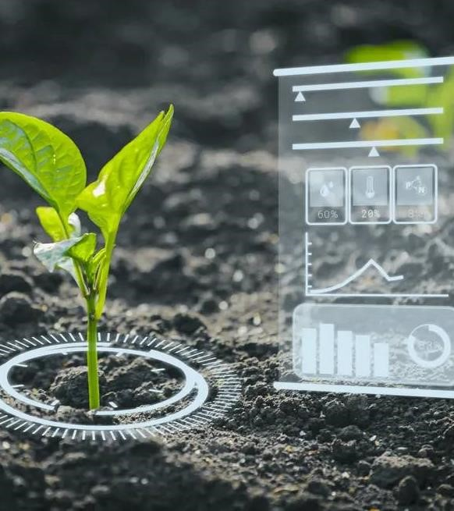

## 2. IoT-Enabled Smart Agriculture

### 2.1. Introduction

In order to meet the current global needs of humanity, new solutions and technologies are constantly being proposed and implemented. This has led to the advent of the Internet of Things (IoT). IoT is defined as the network of all objects that are embedded within devices, sensors, machines, software and people through the Internet environment to communicate, exchange information and interact in order to provide a comprehensive solution between the real world and the virtual world. In recent years, IoT has been applied in a series of domains, such as smart homes, smart cities, smart energy, autonomous vehicles, smart agriculture, campus management, healthcare, and logistics. Series of other IoT applications have been described by Shafique et al.

An illustration of rich and diverse IoT applications for smart agriculture is provided in Figure 1.

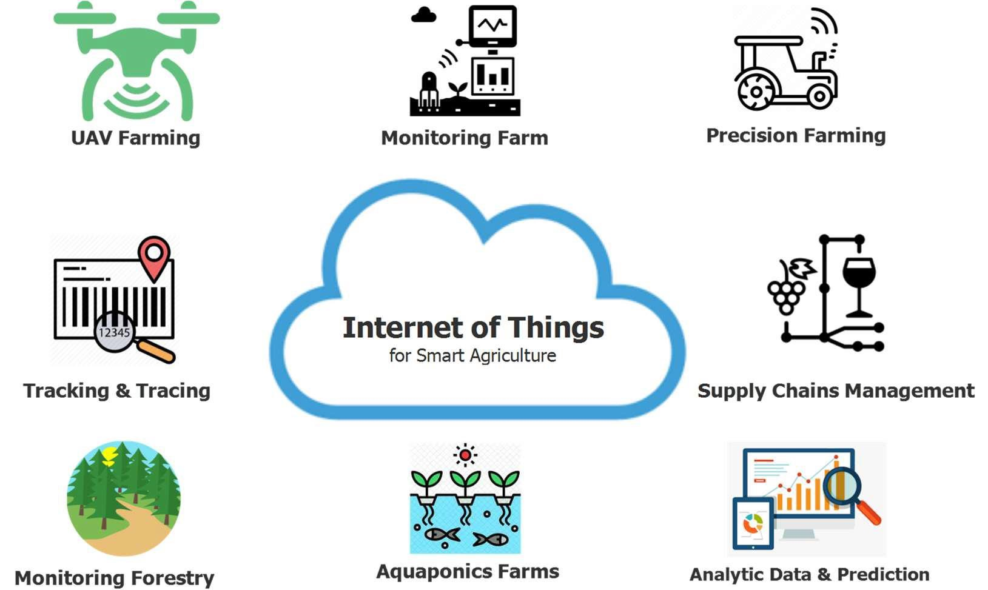

An illustration of IoT applications for smart agriculture.

## 2. IoT-Enabled Smart Agriculture

### 2.2. IoT Ecosystem Architecture for Smart Agriculture

In this section, we present a common framework of an IoT ecosystem for smart agriculture based on three main components, including (1) IoT devices, (2) communication technologies, and (3) data process and storage solutions. An illustration of the IoT ecosystem for smart agriculture is presented in Figure 2.

Figure 2. An illustration of IoT ecosystems’ architecture for smart agriculture.

## 2. IoT-Enabled Smart Agriculture

### 2.2. IoT Ecosystem Architecture for Smart Agriculture

#### 2.2.1 IoT Devices

The common architecture of an IoT device consists of sensors to collect information from the environment, actuators based on wired or wireless connections, and an embedded system that has a processor, memory, communication modules, input– output interfaces, and battery power. The common architecture of a typical IoT device for smart agriculture is shown in Figure 3.

An illustration of the common architecture of an IoT device.

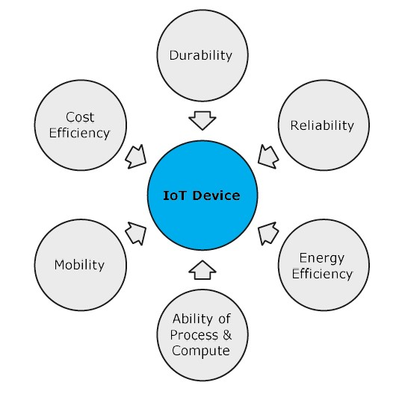

The main characteristics of IoT devices.

## 2. IoT-Enabled Smart Agriculture

### 2.2. IoT Ecosystem Architecture for Smart Agriculture

#### 2.2.2 Communication Technology

The survey of communication technologies for IoT indicated that to integrate IoT into the smart agriculture sector, communication technologies must progressively improve the evolution of IoT devices. They play an important role in the development of IoT systems. The existing communication solutions can be classified as: protocol, spectrum, and topology.

Protocols: many wireless communication protocols have been proposed for the smart agriculture sector. Based on these protocols, devices in a smart agricultural system can interact, exchange information, and make decisions to monitor and control farming conditions and improve yields and production efficiency. The typical, low-power communication protocol numbers commonly used in smart agriculture can be divided into short-range and long-range categories based on the communication range.

Some typical communication technologies for smart agriculture.

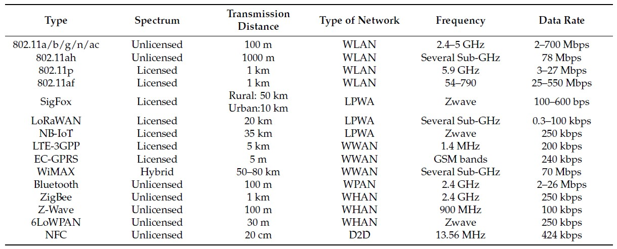

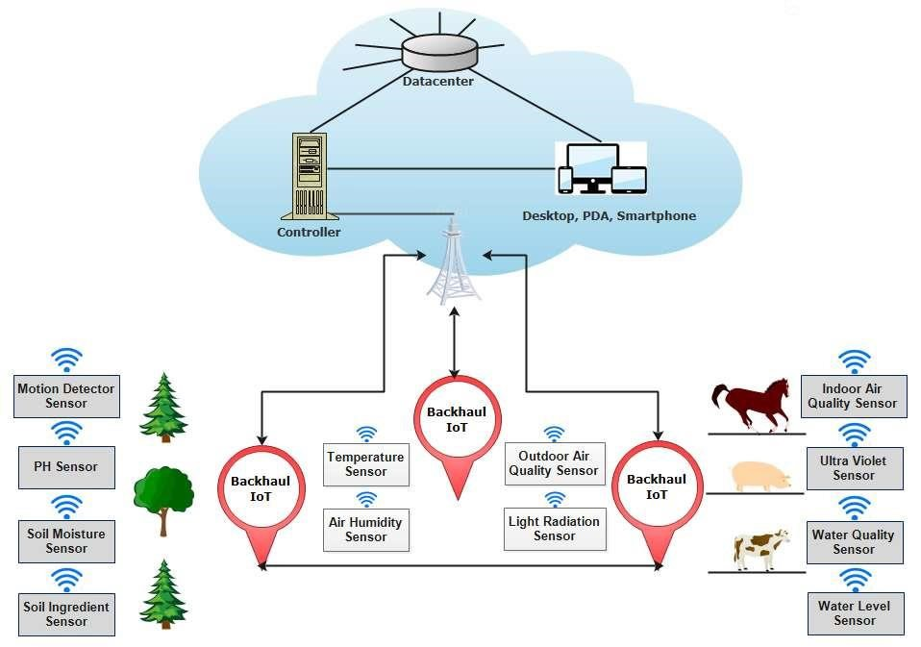

An illustration of the common IoT-based smart agriculture topology.

## 2. IoT-Enabled Smart Agriculture

### 2.3. Typical Applications of IoT in Smart Agriculture

#### 2.3.1 Monitoring

In the agriculture sector, factors affecting the farming and production process can be monitored and collected, such as soil moisture, air humidity, temperature, pH level, etc. These factors depend on the considered agricultural sector. Some smart agricultural sectors are applying the following monitoring solutions:

* Crop Farming
* Aquaponics
* Forestry
* Livestock Farming

## 2. IoT-Enabled Smart Agriculture

### 2.3. Typical Applications of IoT in Smart Agriculture

#### 2.3.2 Tracking and Tracing

In order to meet the needs of consumers and increase profit value, in the future, farms need to demonstrate that products offered to the market are clean products and can be tracked and traced conveniently, thereby enhancing the trust of consumers in product safety and health-related issues.

#### 2.3.3 Smart Precision Farming

The advent of the GPS (global positioning system) has created breakthrough advances in many fields of science and technology. The GPS provides the most important parameters for locating a device, such as location and time. GPS systems have been successfully deployed in many fields, such as smartphones, vehicles, and IoT ecosystems. However, GPS is only good support for outdoor systems and the sky. Meanwhile, the demand for the locating and navigating systems in the home and on the streets of smart cities is growing rapidly. Aiming to solve this problem, an advanced global navigation satellite system (GNSS) is being deployed. Based on GPS and GNSS systems, suitable farming maps have been established for fields and farms. As a result, agricultural machinery and equipment can be operated autonomously.

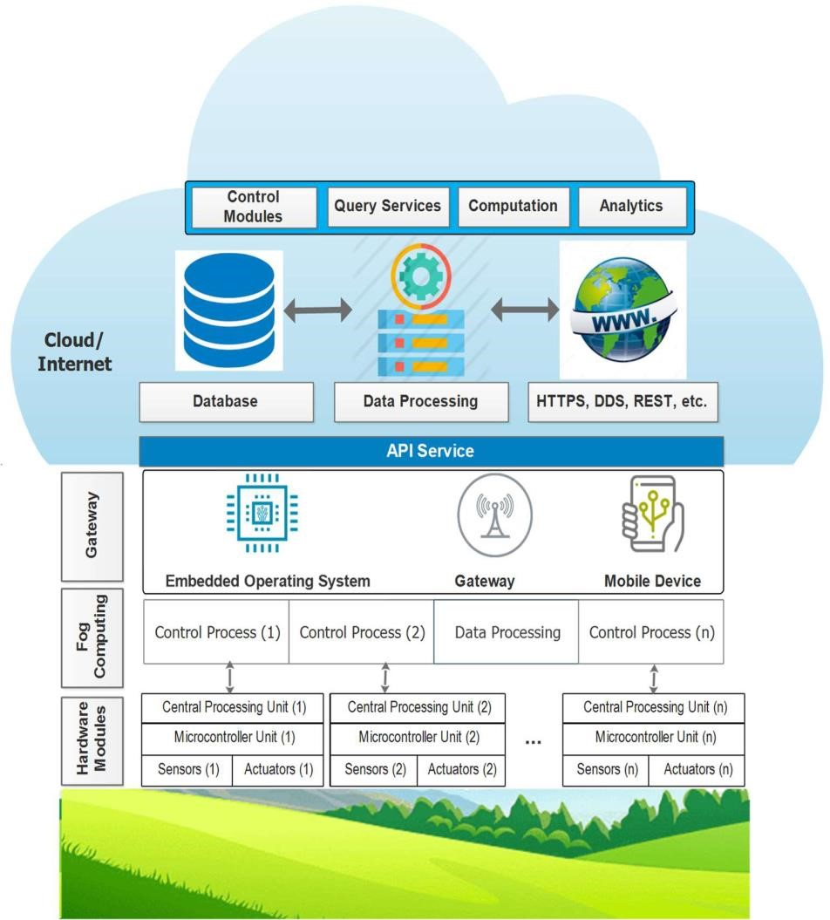

Cloud-assisted IoT-based precision agriculture platform.

## 2. IoT-Enabled Smart Agriculture

### 2.3. Typical Applications of IoT in Smart Agriculture

#### 2.3.4 Greenhouse Production

A greenhouse consists of walls and a roof, which are usually made from transparent materials, such as plastic or glass. In a greenhouse, plants are grown in a controlled environment, including controlling for moisture, nutrient ingredients of the soil, light, temperature, etc. Consequently, greenhouse technology makes it possible for humans to grow any plant, at any time, by providing suitable environmental conditions.

An illustration of IoT application for monitoring farming conditions in a greenhouse.

**3**

**. Precision Farming**

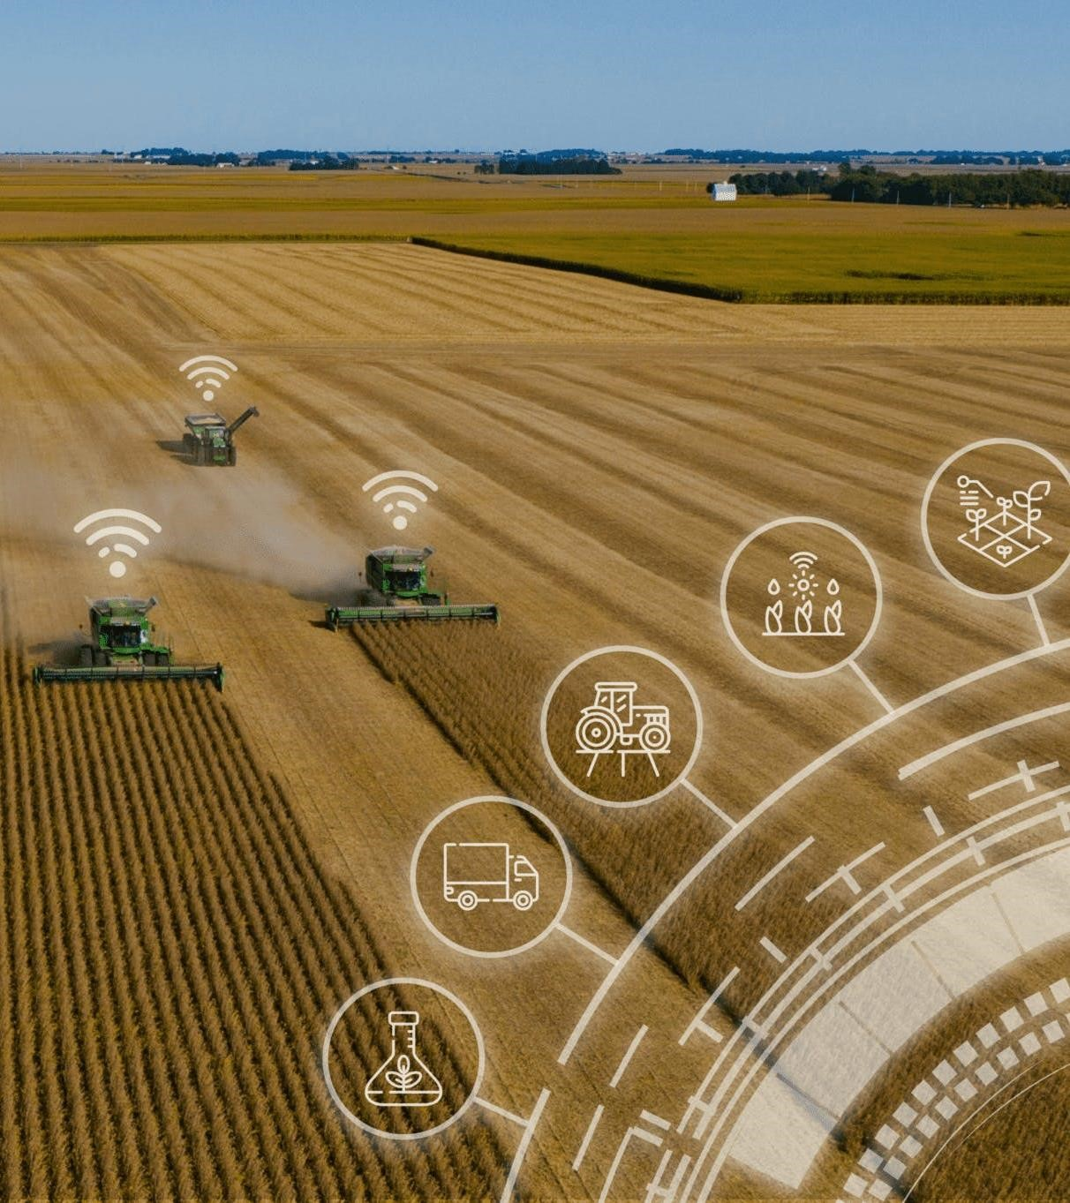

## 3. Precision Farming

### 3.1. An Introduction to Precision Agriculture

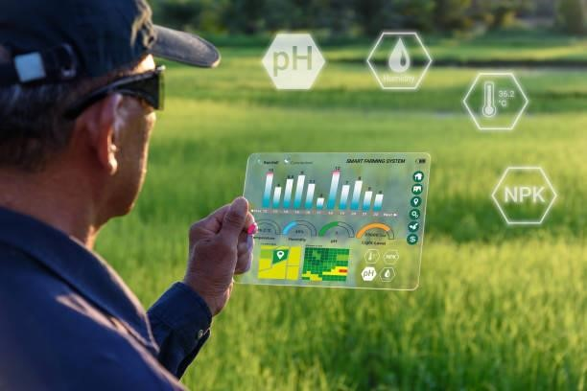Precision agriculture merges the new technologies borne of the information age with a mature agricultural industry. It is an integrated crop management system that attempts to match the kind and amount of inputs with the actual crop needs for small areas within a farm field. This goal is not new, but new technologies now available allow the concept of precision agriculture to be realized in a practical production setting.

Precision agriculture often has been defined by the technologies that enable it and is often referred to as GPS (Global Positioning System) agriculture or variable-rate farming. As important as the devices are, it only takes a little reflection to realize that information is the key ingredient for precise farming. Managers who effectively use information earn higher returns than those who don't.

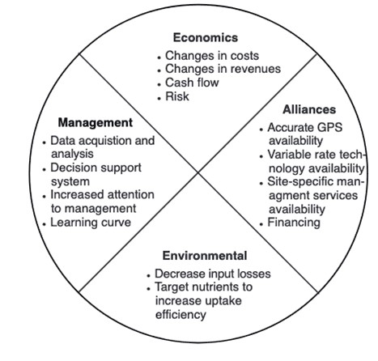

Issues affecting adoption of precision agriculture management.

## 3. Precision Farming

### 3.2. The need for precision agriculture

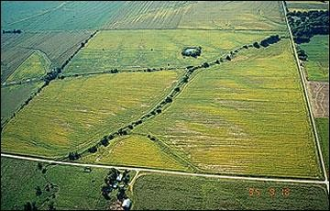Farmers usually are aware that their fields have variable yields across the landscape. These variations can be traced to management practices, soil properties and/or environmental characteristics. Soil characteristics that affect yields include texture, structure, moisture, organic matter, nutrient status and landscape position. Environmental characteristics include weather, weeds, insects and disease.

The aerial photo in front Figure illustrates that in some fields, within-field variability can be substantial. In this field, the best crop growth was near waterways and level areas of the field.

## 3. Precision Farming

### 3.3. Tools of precision agriculture

In order to gather and use information effectively, it is important for anyone considering precision farming to be familiar with the technological tools available. These tools include hardware, software and recommended practices.

#### 3.3.1 Global Positioning System (GPS) receivers

Global Positioning System satellites broadcast signals that allow GPS receivers to calculate their position. This information is provided in real time, meaning that continuous position information is provided while in motion. Having precise location information at any time allows soil and crop measurements to be mapped. GPS receivers, either carried to the field or mounted on implements allow users to return to specific locations to sample or treat those areas.

Uncorrected GPS signals have an accuracy of about 300 feet. To be useful in agriculture, the uncorrected GPS signals must be compared to a land-based or satellite-based signal that provides a position correction called a differential correction. The corrected position accuracy is typically 63-10 feet. In Missouri, the Coast Guard provides differential correction beacons that are available to most areas free of charge. When purchasing a GPS receiver, the type of differential correction and its coverage relative to use area should be considered.

## 3. Precision Farming

### 3.3. Tools of precision agriculture

#### 3.3.2 Yield monitoring and mapping

Grain yield monitors continuously measure and record the flow of grain in the clean-grain elevator of a combine. When linked with a GPS receiver, yield monitors can provide data necessary for yield maps. Yield measurements are essential for making sound management decisions. However, soil, landscape and other environmental factors should also be weighed when interpreting a yield map. Used properly, yield information provides important feedback in determining the effects of managed inputs such as fertilizer, lime, seed, pesticides and cultural practices including tillage and irrigation.

Yield measurements from a single year may be heavily influenced by weather. Examining yield information records from several years and including data from extreme weather years helps in determining if the observed yield level is due to management or is climate-induced.

## 3. Precision Farming

### 3.3. Tools of precision agriculture

#### 3.3.3 Grid soil sampling and variable-rate fertilizer (VRT) application

Historically, the objectives of soil sampling have been to determine the average nutrient status of a field and to provide some measure of nutrient variability in a field. Soil sampling for precision agriculture has these same objectives with some modifications. Instead of a field, producers are interested in areas within fields. They also are interested in relating trends in soil fertilizer levels to other field properties that are predictable or easily measured. Knowledge of factors influencing soil nutrient levels including soil type, topography, cropping history, manure application, fertilizer application and leveling for irrigation will help the producer determine the most effective sampling approach. The basic principles of soil sampling still apply to precision sampling. An adequate number of samples should be collected to accurately characterize nutrient levels. The samples should be collected to the proper depth for nonmobile and mobile nutrients. Samples should be handled and stored to minimize contamination and degradation.

## 3. Precision Farming

### 3.3. Tools of precision agriculture

#### 3.3.4 Remote sensing

Remote sensing is collection of data from a distance. Data sensors can simply be hand-held devices, mounted on aircraft or satellite-based. Remotely-sensed data provide a tool for evaluating crop health. Plant stress related to moisture, nutrients, compaction, crop diseases and other plant health concerns are often easily detected in overhead images. Electronic cameras can also record near-infrared images that are highly correlated with healthy plant tissue. New image sensors with high spectral resolution are increasing the information collected from satellites.

## 3. Precision Farming

**3.3. Tools of precision agriculture**

### 3.3.5 Crop scouting

With planting wrapping up and crops beginning to emerge, now is the time to start scouting fields regularly throughout the growing season for any potential issues. Scouting fields and monitoring crops throughout the growing season can help you make more informed management decisions and stay on top of potential issues that may come up during the growing season. Even if some issues cannot be fixed, regular scouting can help us better understand what happened in the field and make adjustments to reduce issues in the future.

## 3. Precision Farming

**3.3. Tools of precision agriculture**

### 3.3.6 Geographic information systems (GIS)

Geographic information systems (GIS) are computer hardware and software that use feature attributes and location data to produce maps. An important function of an agricultural GIS is to store layers of information, such as yields, soil survey maps, remotely sensed data, crop scouting reports and soil nutrient levels. Geographically referenced data can be displayed in the GIS, adding a visual perspective for interpretation.

In addition to data storage and display, the GIS can be used to evaluate present and alternative management by combining and manipulating data layers to produce an analysis of management scenarios.

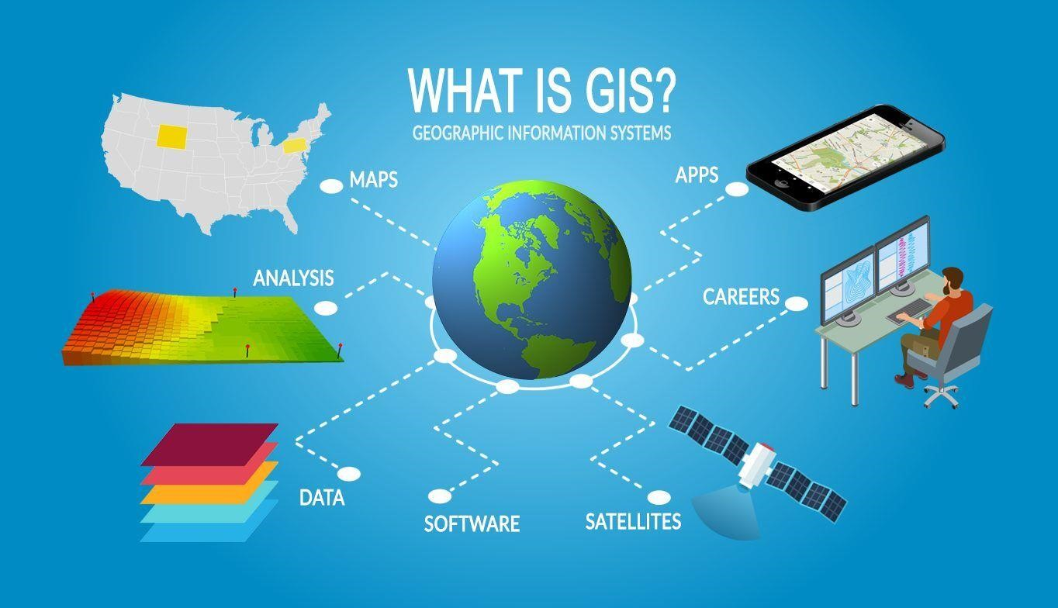

## 3. Precision Farming

**3.3. Tools of precision agriculture**

### 3.3.7 Information management

The adoption of precision agriculture requires the joint development of management skills and pertinent information databases. Effectively using information requires a farmer to have a clear idea of the business' objectives and of the crucial information necessary to make decisions. Effective information management requires more than record-keeping analysis tools or a GIS. It requires an entrepreneurial attitude toward education and experimentation.

## 3. Precision Farming

**3.3. Tools of precision agriculture**

### 3.3.8 Identifying a precision agriculture service provider

Farmers should consider the availability of custom services when making decisions about adopting site-specific crop management. Agricultural service providers may offer a variety of precision agriculture services to farmers. By distributing capital costs for specialized equipment over more land and by using the skills of precision agriculture specialists, custom services can decrease the cost and increase the efficiency of precision agriculture activities.

**4**

**. Climate**

**-**

**Smart Agriculture**

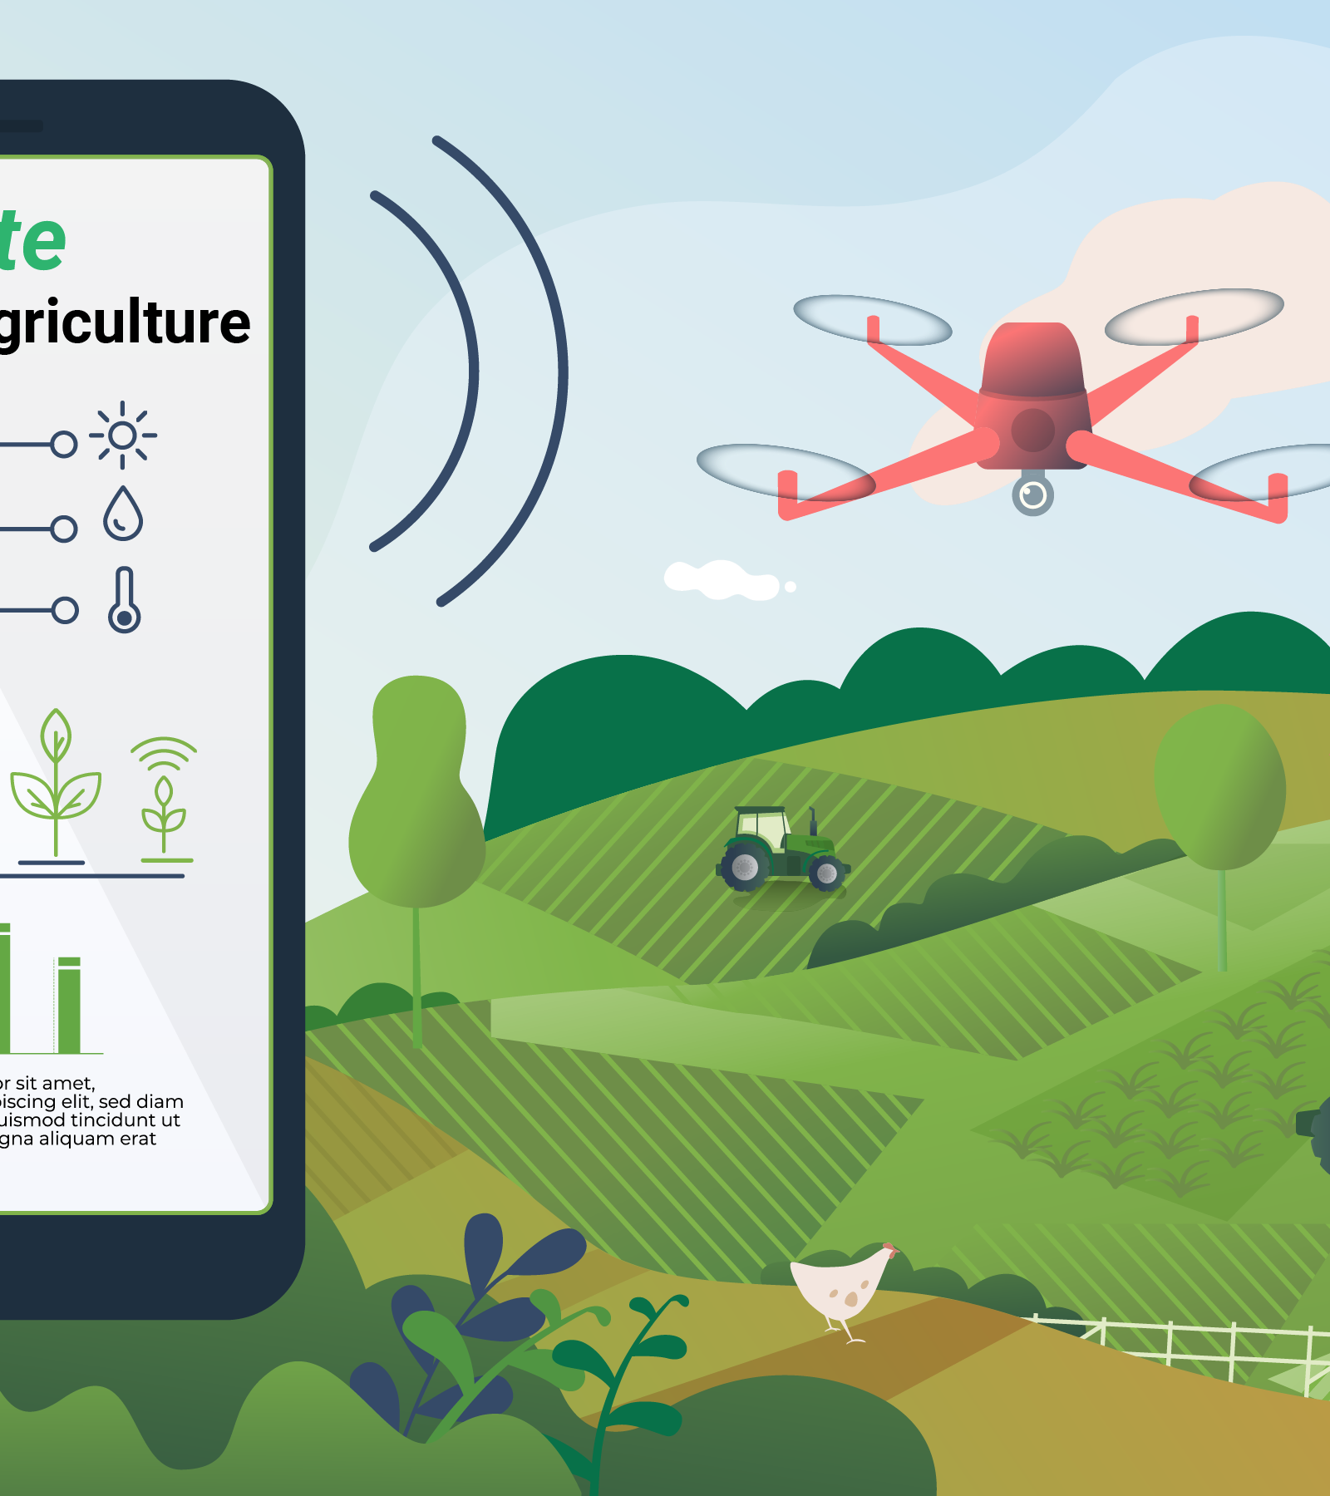

## 4. Climate-Smart Agriculture

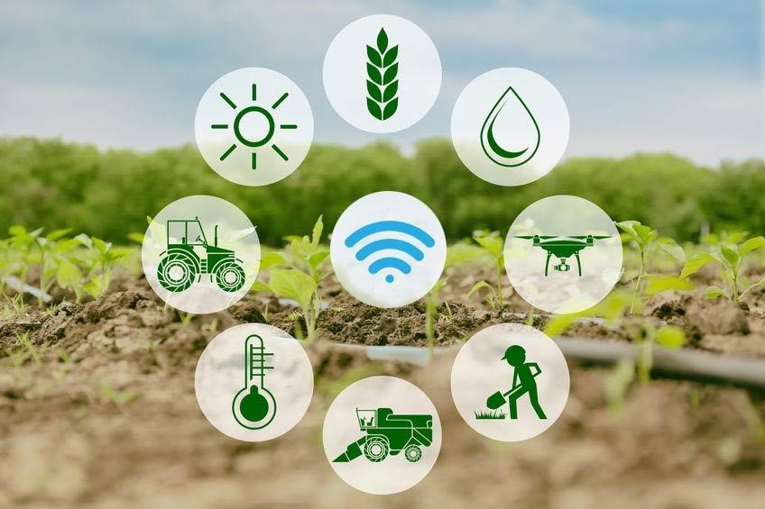**4.1. Why climate-smart agriculture, forestry and fisheries?**

Agriculture has to address simultaneously three intertwined challenges: ensuring food security through increased productivity and income, adapting to climate change and contributing to climate change mitigation (FAO, 2010a; Foresight, 2011a; Beddington et al., 2012a; Beddington et al., 2012b; HLPE, 2012a). Addressing these challenges, exacerbating global pressure on natural resources, especially water, will require radical changes in our food systems. To address these three intertwined challenges, food systems have to become, at the same time, more efficient and resilient, at every scale from the farm to the global level. They have to become more efficient in resource use (use less land, water, and inputs to produce more food sustainably) and become more resilient to changes and shocks.

It is precisely to articulate these changes that FAO has forged the concept of climate-smart agriculture (CSA) as a way forward for food security in a changing climate. CSA aims to improve **food security**, **help communities adapt to climate change and contribute to climate change mitigation** by **adopting appropriate practices**, **developing enabling policies** and **institutions and mobilizing needed finances**.

## 4. Climate-Smart Agriculture

**4.1. Why climate-smart agriculture, forestry and fisheries?**

**Key messages:**

* Agriculture and food systems must undergo significant transformations in order to meet the related challenges of food security and climate change.
* Increasing resource efficiency is essential both to increase and ensure food security on the long term and to contribute to mitigate climate change.
* Building resilience to every type of risk is essential to be prepared for uncertainty and change.
* Efficiency and resilience have to be considered together, at every scale and from both environmental, economic and social perspectives.
* Implementing climate-smart agriculture can be a major driver of a Green Economy and a concrete way to operationalize sustainable development.
* Addressing food security and climate change requires concerted and coordinated involvement and action of all stakeholders on a long term perspective.
* Climate smart agriculture is not a new agricultural system, nor a set of practices. It is a new approach, a way to guide the needed changes of agricultural systems, given the necessity to jointly address food security and climate change.

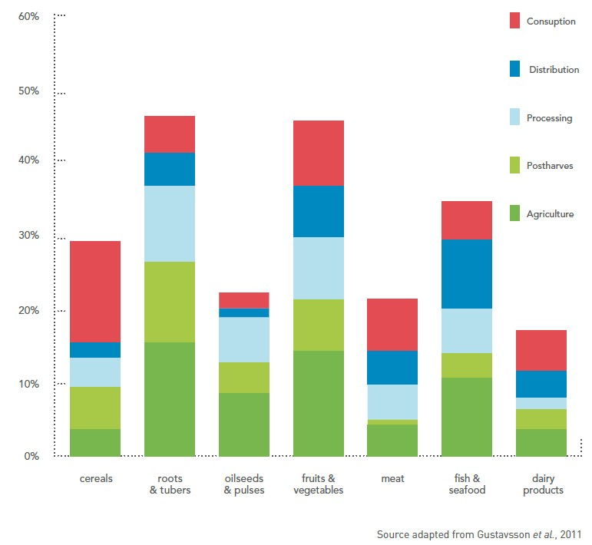

Global food losses.

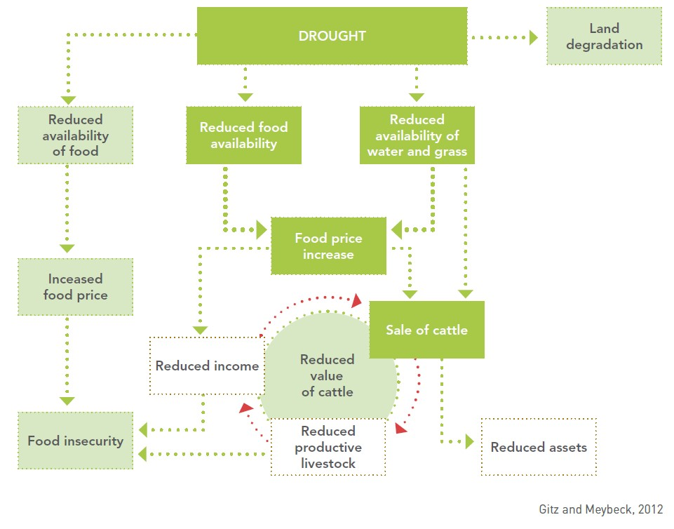

Impacts of drought.

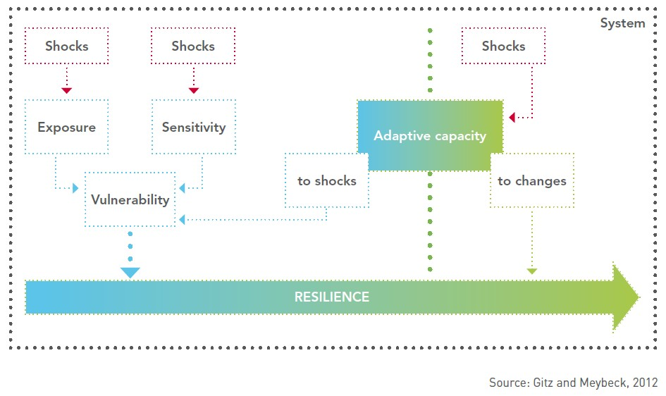

Components of resilience

## 4. Climate-Smart Agriculture

### 4.2. Water management

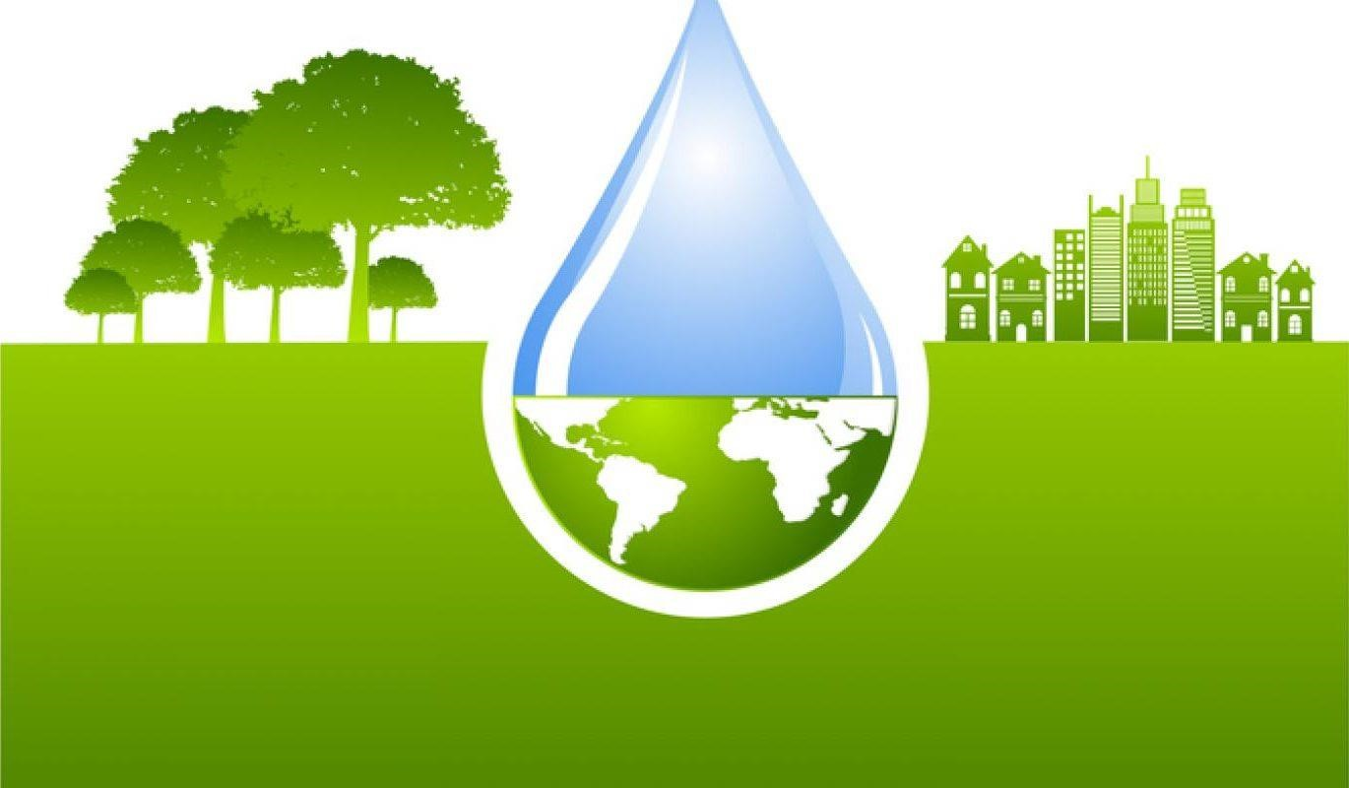This section examines the overall development context in which water is managed in agriculture and provides an overview of the current status, trends and challenges. It also reviews the current state of knowledge of the impact of climate change on water for agriculture and the vulnerability of rural populations and farming systems to climate change. This is followed by an examination of possible response options for addressing these impacts. These options can be applied at various scales, on individual farms, in larger irrigation schemes, throughout entire river basins and at the national level. The module also presents criteria for prioritizing response options, examines conditions for climate change adaptation and reviews opportunities for climate change mitigation.

## 4. Climate-Smart Agriculture

**4.2. Water management Key messages:**

* Most of the impacts of climate change on agriculture are expected to result from changes in the water cycle. Because of this, the design of climate-smart agriculture (CSA) strategies will need to be viewed though a ‘water lens’.
* Climate change will affect both rainfed and irrigated agriculture through increased crop evapotranspiration, changes in the amount of rainfall, and variations in river runoff and groundwater recharge. The impact of climate change on water use in agriculture must be considered within a wider context in which a number of issues are taken into account including: increased water demand by all sectors; the degradation of water quality; and heightened competition for water at various levels (community, river basin and aquifer).
* Climate change adaptation in water includes a range of response options related to policies, investments, water management, and institutional and technical factors. These options will need to be applied at different scales: on fields and farms; in irrigation schemes; in watersheds or aquifers; in river basins and at the national level.
* Climate-proofing will have to become central in the design of future investment plans in water for agriculture. It will become necessary to maintain a clear perspective on resilience when screening water development programmes. When designing development policies it will be necessary to systematically consider how the policies may be affected by climate change. In many cases, the challenge will be to combine more efficient use of water with increased resilience of production systems.

To watch the video of this slide, refer to the video presentation.



Climate change and development: how they influence water supply and demand

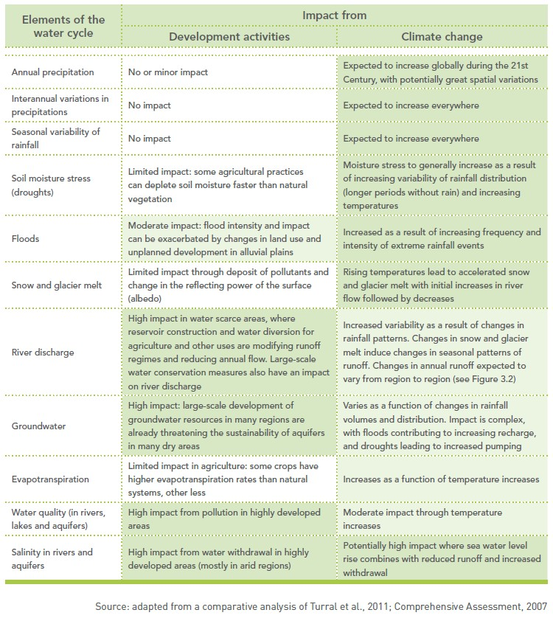

## 4. Climate-Smart Agriculture

### 4.3. Soils and their management for Climate-smart agriculture

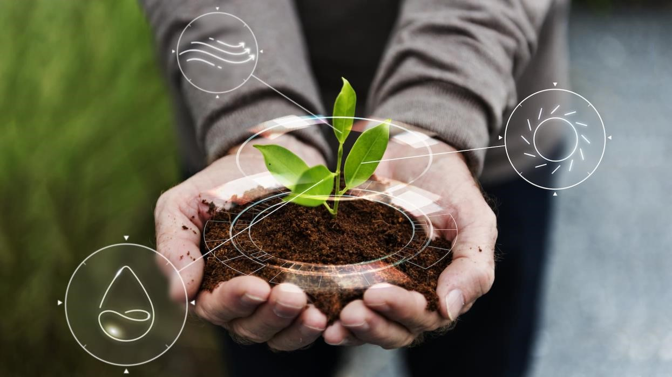This section looks at soil management in the context of climate change. It begins with an overview of some of the principles of soil health and the way soils interact with the atmosphere and with terrestrial and freshwater ecosystems. Sustainable soil management options are presented as “winwin-win” strategies that sequester carbon in the soil, reduce greenhouse gas (GHG) emissions and help intensify production, all while enhancing the natural resource base. The module also describes practices that contribute to climate change adaptation and mitigation, and build the resilience of agricultural ecosystems.

## 4. Climate-Smart Agriculture

**4.3. Soils and their management for Climate-smart agriculture Key messages:**

* Knowing the status and condition of soils and their properties is fundamental for making decisions about sustainable soil management practices that contribute to climate-smart land use.
* Soils that have been degraded are at much greater risk from the damaging impacts of climate change. Degraded soils are vulnerable due to serious losses of soil organic matter (SOM) and soil biodiversity, greater soil compaction and increased rates of soil erosion and landslides. In addition, land degradation is itself a major cause of climate change.
* Management practices that increase soil organic carbon (SOC) content through organic matter management rather than depleting it will bring win-win-win benefits. These practices will maintain productive soils that are rich in carbon, require fewer chemical inputs and sustain vital ecosystem functions, such as the hydrological and nutrient cycles.
* The sound management of the interrelations among soils, crops and water can increase SOM, improve the soil’s capacity to retain nutrients and water, and enhance soil biodiversity. Integrated management practices can create optimal physical and biological conditions for sustainable agricultural production (including food, fiber, fodder, bioenergy and tree crops, and livestock).

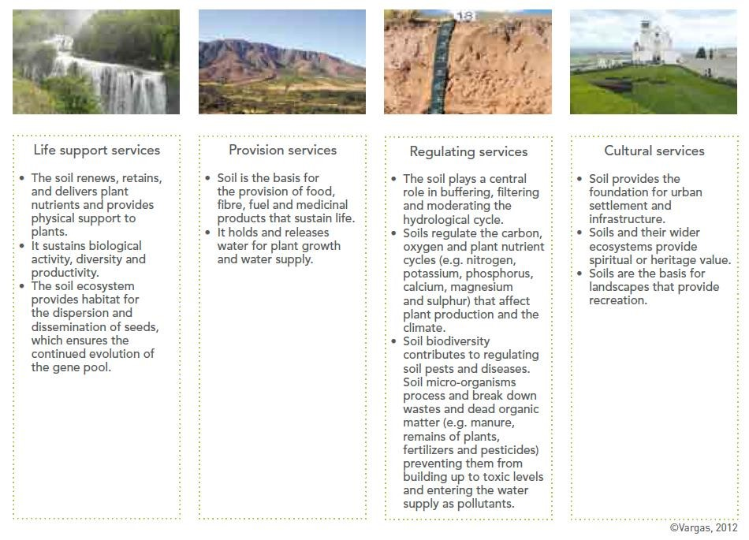

To watch the video of this slide, refer to the video presentation.



To watch the video of this slide, refer to the video presentation.



**5**

**. Smart agriculture in the Islands**

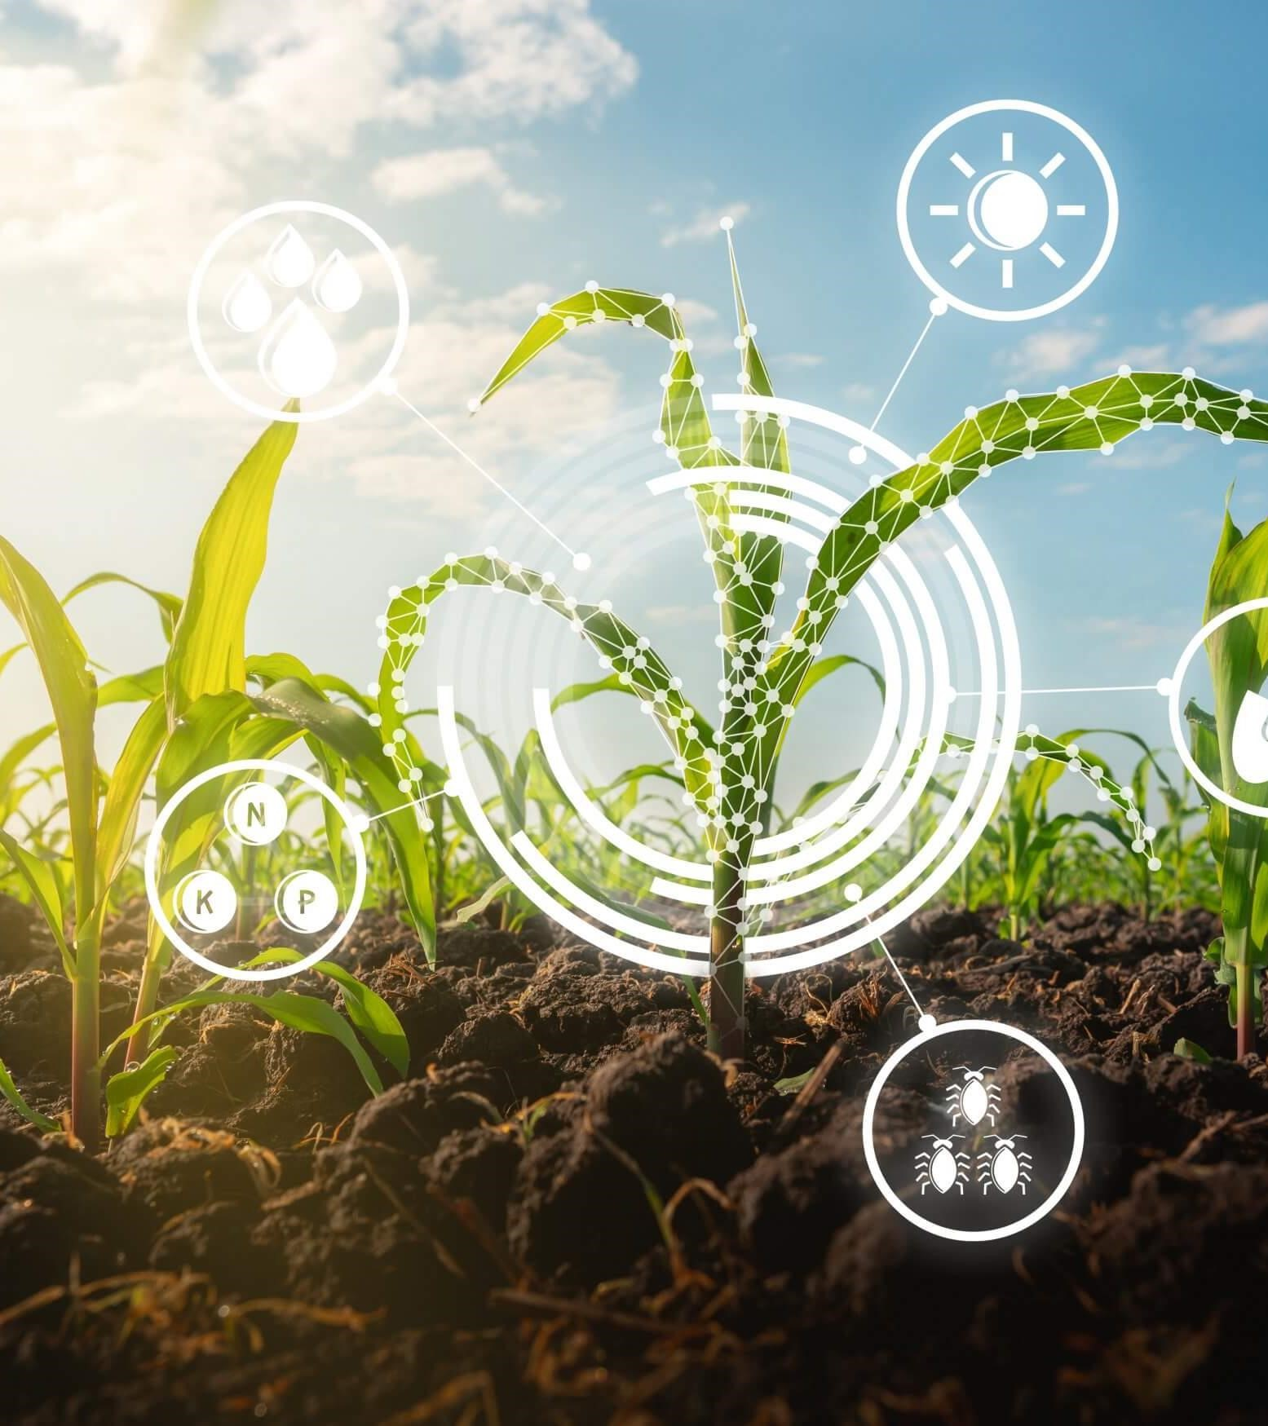

## 5. Smart agriculture in the Islands

**5.1 Smart Islands**

Smart Islands is a programme that adopts an innovative approach to deliver connectivity and scalable and sustainable services to disadvantaged island communities. The Smart Islands programme aims at transforming rural and coastal communities and improving their well-being and livelihood by connecting them to a range of digitally enabled services. The programme, built on the ITU-led Smart Villages initiative piloted in Niger and being developed in Egypt and Pakistan, adopts an innovative approach to deliver connectivity and scalable and sustainable services to disadvantaged island communities.

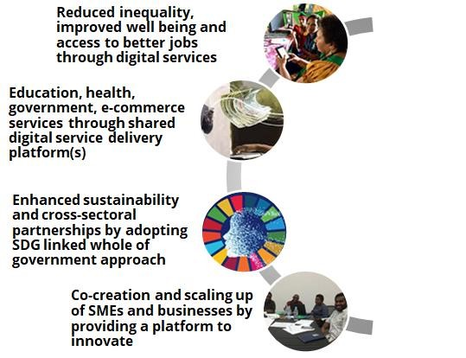

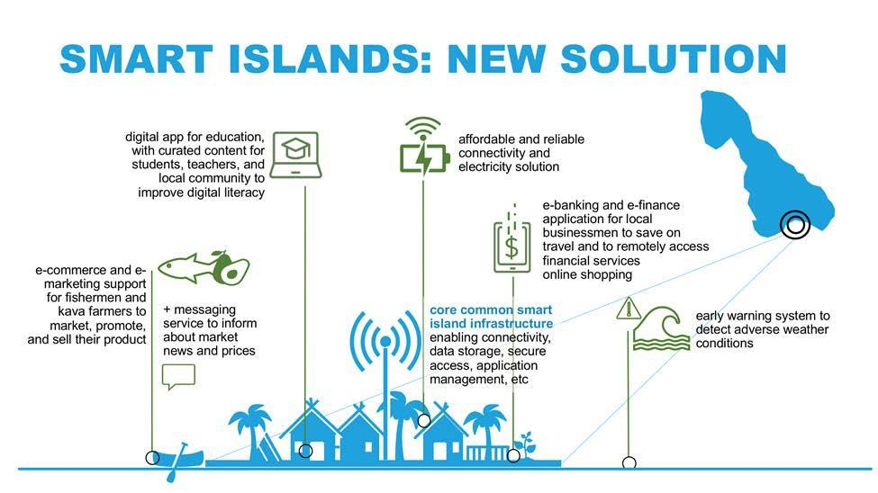

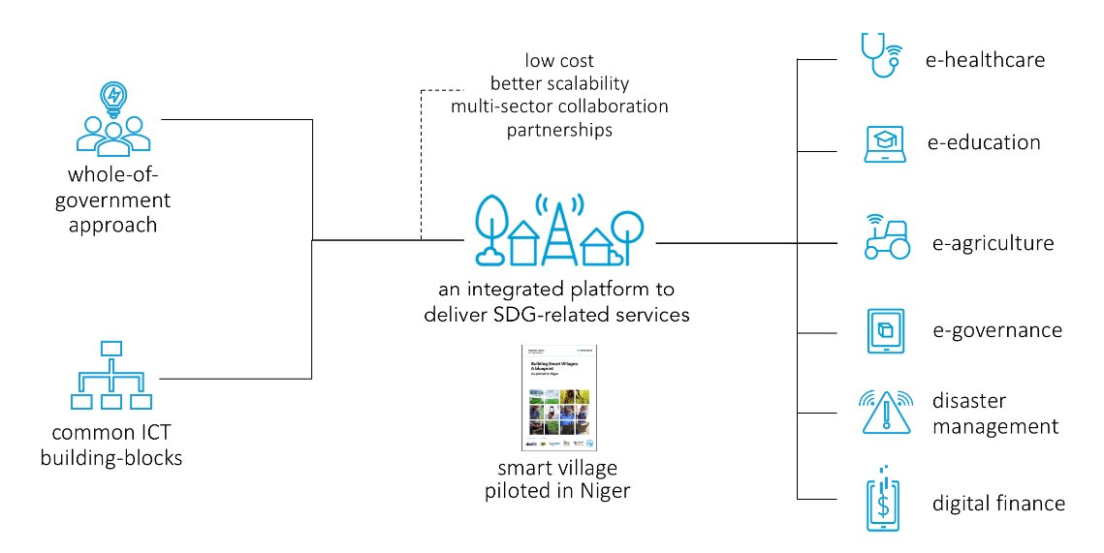

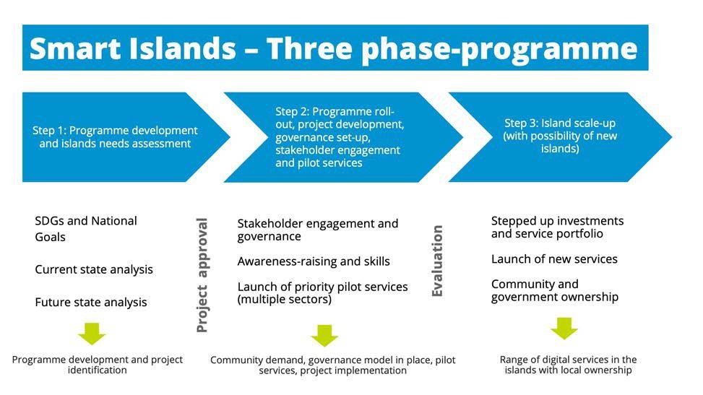

Phased approach to the Smart Islands Vanuatu Programme

## 5. Smart agriculture in the Islands

### 5.2 The capability of smart Islands for smart agriculture

Small island developing states (SIDS) are often characterized by their size, remoteness, and bountiful marine resources. Highly dependent on fisheries for food, these island nations face agricultural limitations resulting in a heavy reliance on imports. Import dependency is fraught with issues such as volatile food prices and food/nutrition insecurity. As sea-levels rise and freshwater sources diminish, island nations face increasing agricultural challenges and [food](http://www.sustainablesids.org/wp-content/uploads/2018/06/IFAD_-SIDS.pdf) [security](http://www.sustainablesids.org/wp-content/uploads/2018/06/IFAD_-SIDS.pdf) issues.

Farming is often small-scale and family-run. Limited investment in commercial agriculture and farming technology greatly impedes export markets, meaning agriculture products are simply not competitive commodities. While agriculture carries its economic issues, it also shines a light on [gender](https://sustainabledevelopment.un.org/content/documents/2231Food%20Security%20and%20Nutrition%20in%20SIDS.pdf) [inequality](https://sustainabledevelopment.un.org/content/documents/2231Food%20Security%20and%20Nutrition%20in%20SIDS.pdf). Women and girls play a large (and often invisible, unpaid) role in agriculture. Women plant, weed, harvest, and process crops, providing for their families.

## 5. Smart agriculture in the Islands

### 5.3 Climate Smart Agriculture in Small Island Developing States

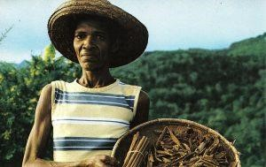As a member of SIDS, Seychelles faces these agricultural challenges. In the Seychelles, fisheries, tourism, and the seafood industry dominate much of the economy, while agriculture makes up a mere 2.07% of the nation’s gross domestic product (GDP). In terms of food-related commodities, the Seychelles’ total exports is USD 8 million while their total imports are USD 126 million. The country is highly dependent on food imports, with 80% of food being imported. This means that the local agriculture productions are too small for the nation to be self-reliant.

## 5. Smart agriculture in the Islands

**5.3 Climate Smart Agriculture in Small Island**

### Developing States

Although completely surrounded by water, the Seychelles has about 1,540 hectares (or roughly 3,805 acres) of agricultural land, representing 3.4% of the total land area in the county. Of that land, only 0.3% is considered arable and 3% of land area constitutes permanent crops. The food production includes tropical fruits, such as bananas and mangoes, and root vegetables such as yams and cabbages. A majority of agriculture in the Seychelles relies on rainfall, although there are irrigations systems. The agriculture input is further lowered through a limited use of fertilizers and pesticides.

## 5. Smart agriculture in the Islands

### 5.3 Climate Smart Agriculture in Small Island Developing States

Inter cropping refers to planting crops in between rows of trees. In the Seychelles, intercropping works as a natural pest repellant, improves soil structure, and balances fertility levels of the soil. Anti-erosion measures refer to practices that mitigate erosion. Examples of such include planting grasses along the outer areas of farms as a means of filtering sediments, excess nutrients, or pesticides from water runoff.

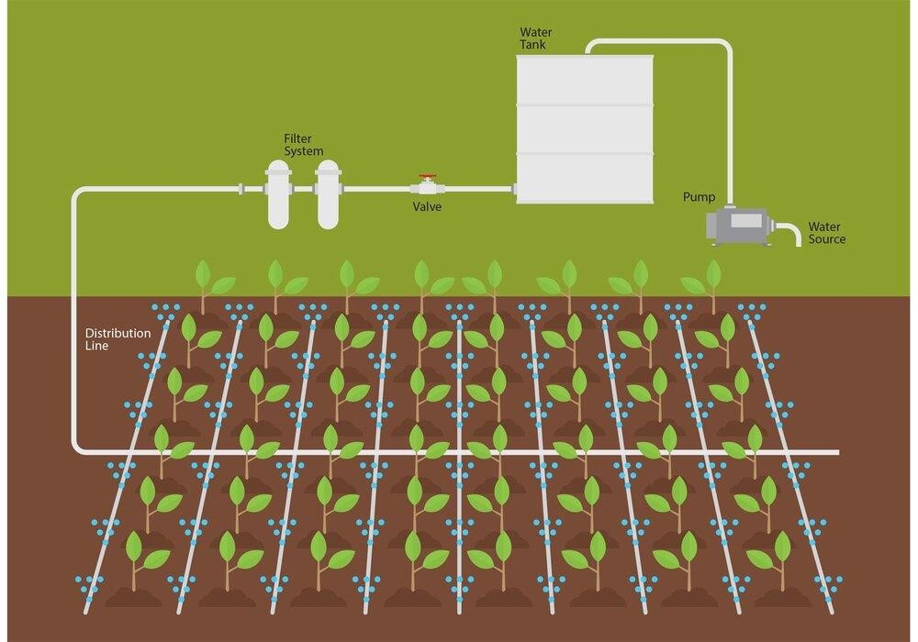

### SMART WATER MANAGEMENT AS CLIMATE CHANGE ADAPTATION

